

**WHCC HOA 2024 Fall Newsletter**

Fall is upon us, and your WHCC HOA Board would like to update the White Hawk residents with a partial year in review.

Seeing all of the activity throughout our neighborhood during the year, it appears our residents enjoyed a busy and productive summer! The Board has seen numerous property improvements constructed this year including pools, pergolas, outdoor kitchens and other beautiful landscape features that enhance our community.

**Welcome to our new neighbors!!**

**Kurt & Aaron Graves - Sonoma Court  
Shayna & Dawson Price - Sonoma Court**

**James & Rachel Sarkey - Kendall Court**

**Vankatrama & Amitha Garlapati - Chalone Court**

The WHCC HOA Board has also had a busy year. The Board has been able to complete the following so far in 2024:

1. Straightened 5 stop signs with new concrete in base
2. Replaced 4 stop signs that were faded
3. Purchased and installed street name replacement
4. Completed sprinkler system repairs
5. Completed mulch program and edging around mulch areas
6. Completed financial record keeping program
7. Sent spring newsletter
8. Completed update of HOA website
9. Completed email database for resident communications
10. Rock replacing the mulch area was completed.
11. Secretary of State licensing up to date
12. Completed street sign name labels
13. Installed new landscape in median area

**Much More to Come!!**

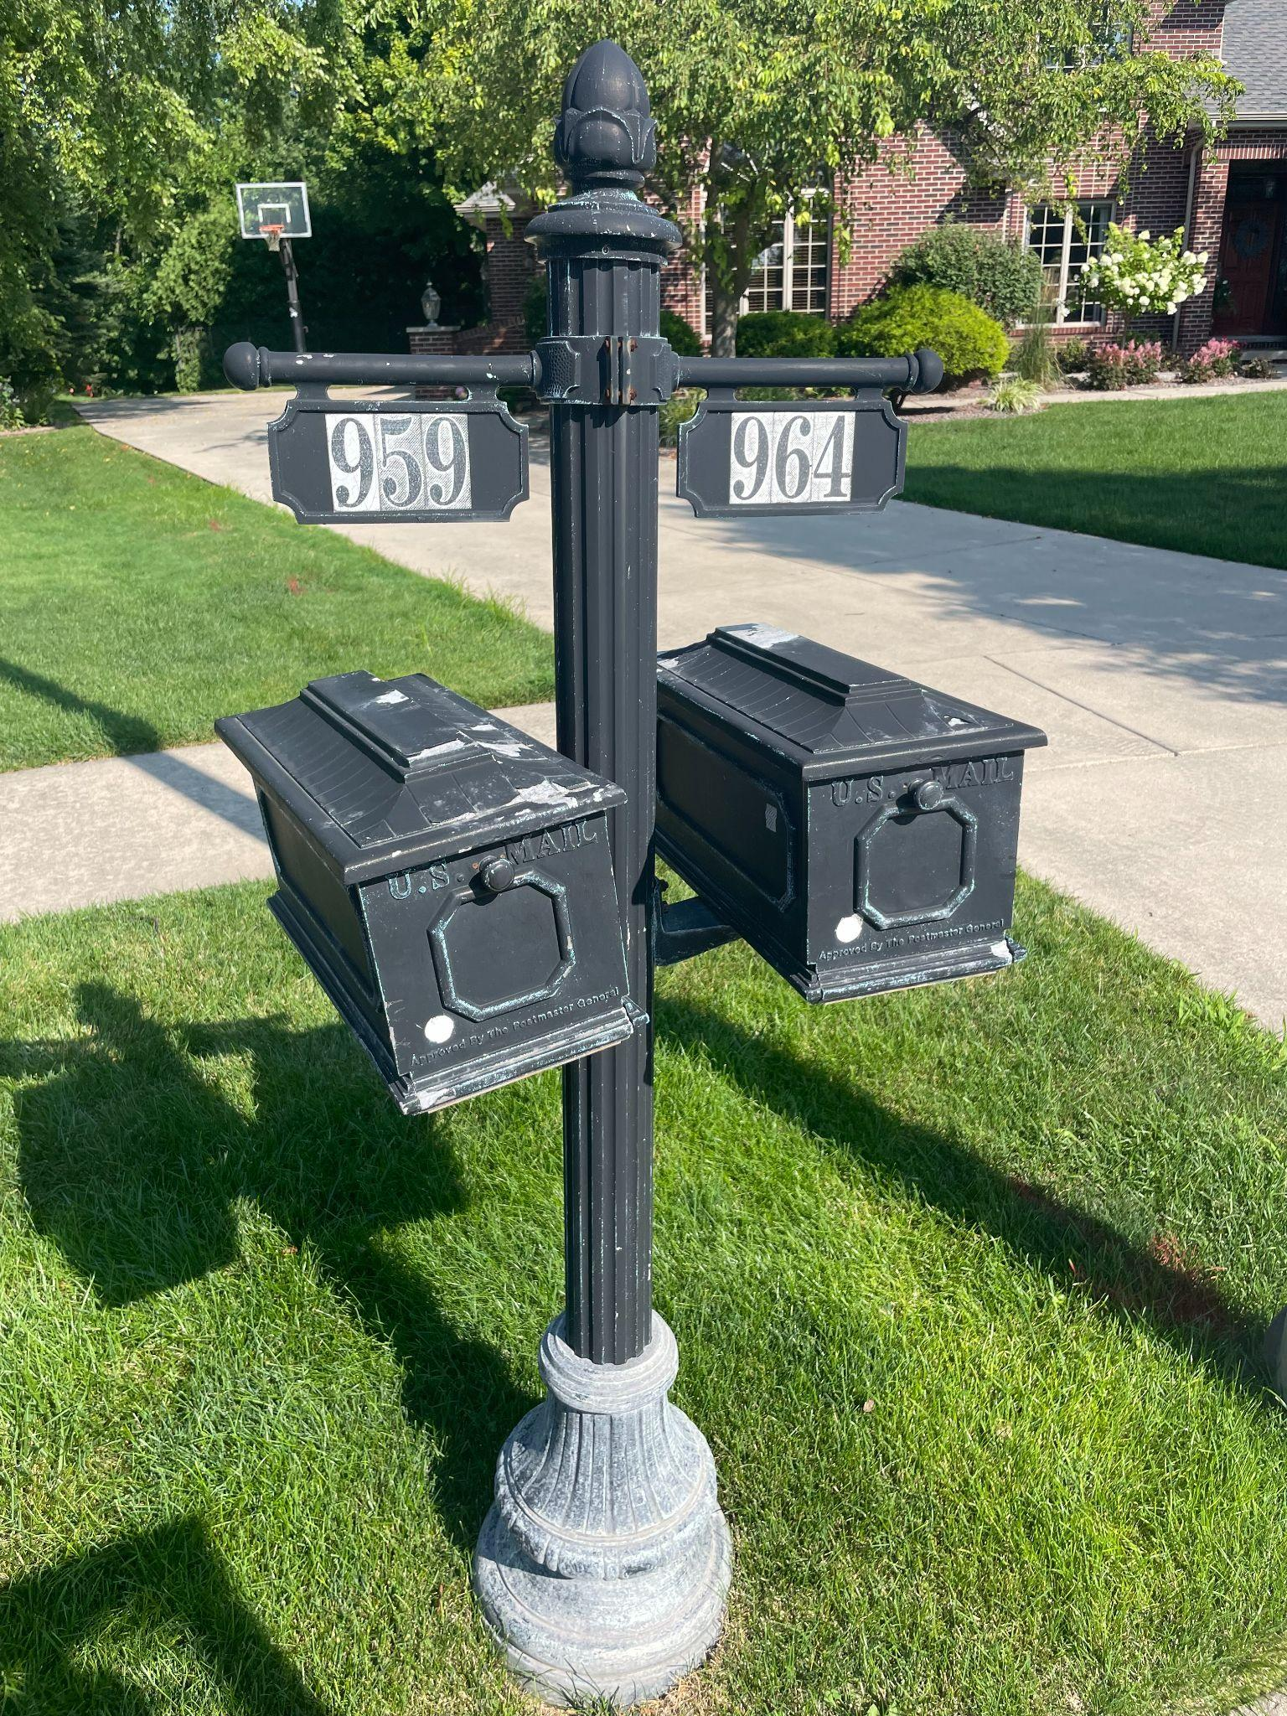 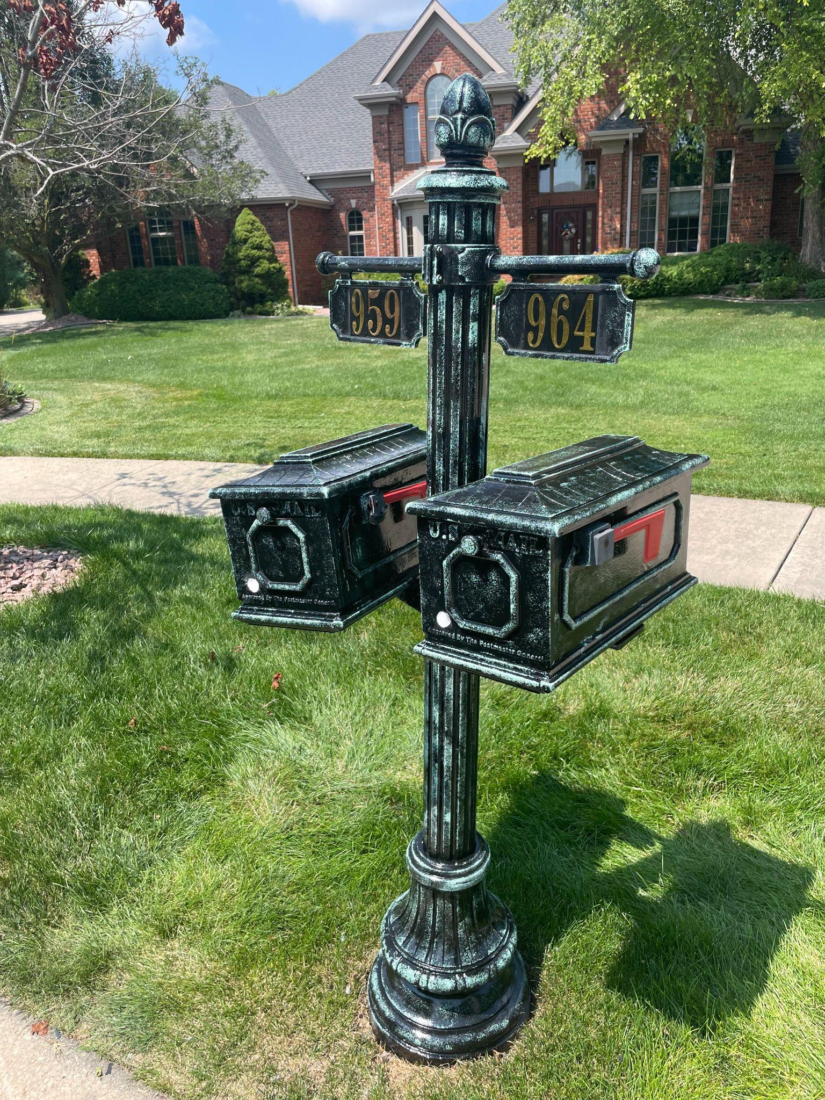

**Mailbox Refurbishment Available! Total Mailbox Makeover - $275**

Procedure:

* Remove corrosion
* Brush, sand and prep base down to aluminum
* Wipe of residual debris
* Pain base coat of “Black Solvent Paint”
* Sponge paint “Verde Green” if desired
* Install new numbers on mailbox
* Light Pole refurbishment available upon request

**Call or text Mikey (219) 776-5843**

**The Board needs your feedback:**

One of the projects slated for 2025 is the repair of the existing inoperable security camera system for our community. Our thoughts are to upgrade the system to include 4K camera resolution, night vision and license plate recognition. When the security camera system was fully operational, the system served to identify 2 instances of property damage caused by vehicles. This enabled the HOA to recover insurance claims to pay for the damage. We estimate the cost of the camera upgrade to be between $25,000 to $30,000. We have not pursued competitive bids at this time as we would like to hear from the community on their thoughts of this proposal. Please e-mail the WHCC HOA Board at [whitehawkcchoa@gmail.com](mailto:whitehawkcchoa@gmail.com) with your thoughts and feedback.

**Friendly Reminder**

Golf carts that are driven on the street need to be operated by a licensed driver at all times. We have had instances and near miss accidents when golf carts have been operated by an unlicensed or underage driver. Let’s avoid any potential tragedy by thoughtfully enforcing this policy.

The golf course is a beautiful accessory to our community. The golf course is private property however, and should not be used for walking, biking, jogging or personal use at any time. Liability issues arise when personal use of the golf course occurs. Please enjoy and respect the course.

We have had a warm and wet summer. These conditions provide for ideal growth for trees, shrubs and bushes. Please be cognizant of the exterior appearance of your home and the maintenance of your property. A concerted effort by the community to maintain property enhances the beauty of our community and supports higher real estate values.

**Always reach out to the HOA Board when considering exterior home improvement projects. Not all projects require approval per the covenants, however, it’s advisable to reach out via e-mail to the HOA Board to determine whether approval is required to avoid any miscommunications.**